Fast tomography experiments

Note: CoolSnap dark current is 94 for this data. Really fast images should be processed with this, rather than 100.

Beads_CoolSnap_A
Binned, 0.27 second exposure, 33.269 keV
Rotation axis was off a little, and too much absorption
Beads_CoolSnap_B
Binned, 0.27 second exposure, 33.069 keV, after moving rotation axis 33 microns
Beads_CoolSnap_C
Unbinned, 1.08 second exposure, 33.069 keV

Then try doing fast tomography with CoolSnap
Beads_CoolSnap_Fast_A
Binned, 0.05 second exposure, 1.665 degrees/sec
108.1 seconds total, 0.150 second/frame
Beads_CoolSnap_Fast_B
Binned, 0.02 second exposure, 2.082 degrees/sec
86.5 seconds total, 0.120 seconds/frame
Beads_CoolSnap_Fast_B
Unbinned, 900 angles, 0.02 second exposure, 1.665 degrees/sec
108.1 seconds total, 0.120 seconds/frame

Switch to Grasshopper 3.

Images look very good.
Discovered that I can run as slow as 1 frame/s by reducing the bandwith to 2%. Can to 0.95 sec exposure, which is fine.
Dorthe’s sample, 33.069 keV, 16-bits, gain=2
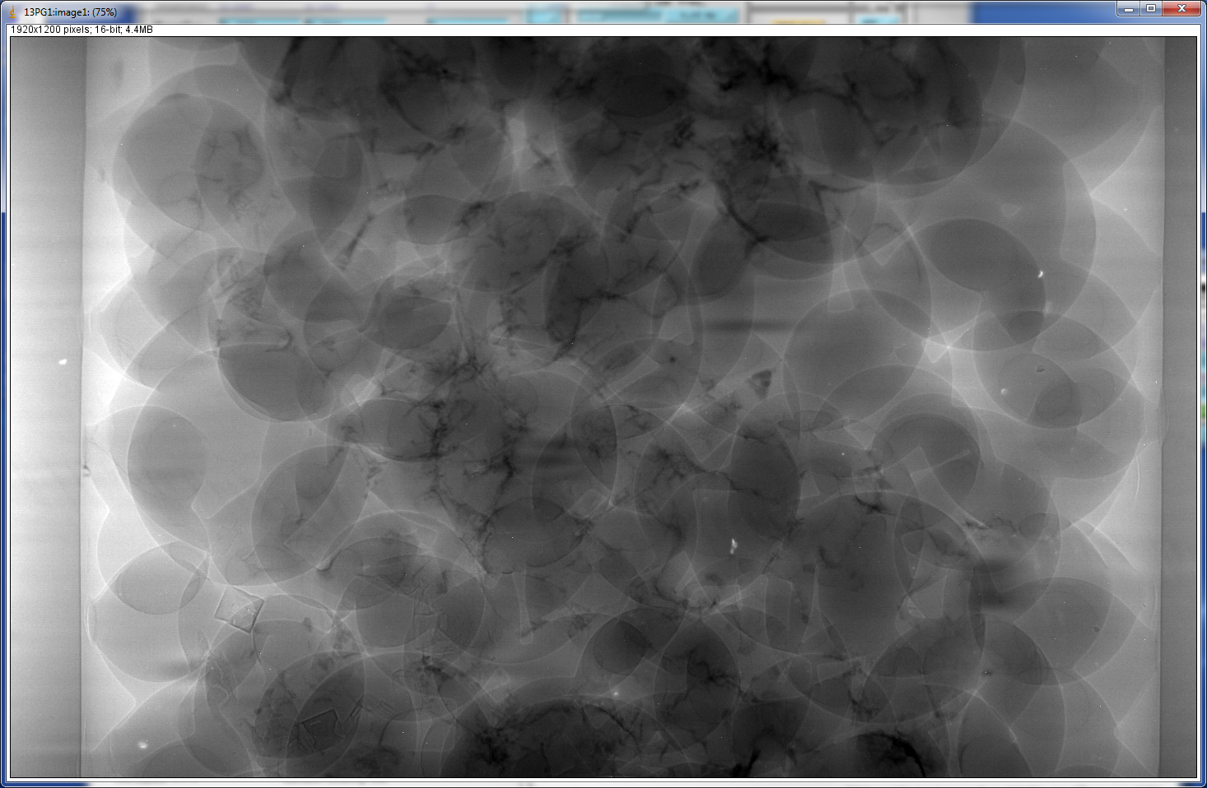
Got camera working in triggered mode. It would not trigger directly from SIS3820, needed to stretch the pulses with Tabor AWG.
Image of slits is tilted, need to adjust with pin.
Got within 1 pixel by rotating mirror.
Measure pixel size: 3.18 microns/pixel unbinned

Manually collect a tomography dataset.
Dorthe_A
Unbinned, 1 second per frame, but only 0.4 seconds of acquisition (need to figure this out). 900 angles, reconstruction looks great.
Dorthe_B.
Binned, 0.02 seconds acquire per frame, 5 degrees/sec, .2 deg/frame, 25 frames/sec, 36 seconds total.
Dorthe_C
Binned, .23 seconds acquire, .25 sec/frame, .8 deg/s, .2 deg/frame. This was free-running, not triggered.
Dorthe_D
Binned, 4 frames/sec, bulb trigger, 85% duty cycle. = .2125 sec exposure time
Dorthe_E
Unbinned, 1 frame/sec, bulb trigger, 85% duty cycle = 0.85 sec exposure time, .2deg/s, 900 angles
Dorthe F
Binned, 80 frames/sec, ext. normal trigger, 6 ms exposure time, 8-bit, 11.25 seconds total
Dorthe_G
Unbinned, 80 frames/sec, ext. normal trigger, 6 ms exposure time, 8-bit, 11.25 seconds total

